Project Design Phase
Problem – Solution Fit Template
Date | 18 June 2026
Team ID
Project Name | E-Commerce Website
Maximum Marks | 4 Marks
Problem – Solution Fit Template
The Problem–Solution Fit means identifying the challenges faced by online shoppers and providing an effective e-commerce platform that addresses those challenges. The solution should simplify product discovery, purchasing, payment processing, and order tracking while enhancing customer satisfaction.
Purpose
- Provide customers with a convenient online shopping experience.
- Simplify product search and comparison.
- Enable secure and fast online transactions.
- Improve customer satisfaction through easy order management and tracking.
- Help businesses reach a larger customer base and increase sales.
Problem | Existing Situation | Proposed Solution | Customer Benefit
Difficulty finding products | Customers spend time searching across multiple websites. | Advanced search and product categorization. | Faster product discovery.
Limited product comparison | Customers find it difficult to compare product features and prices. | Product comparison and filtering features. | Better purchasing decisions.
Insecure payment concerns | Customers worry about payment security. | Secure payment gateway integration (Razor pay/Stripe). | Safe and reliable transactions.
Complex order tracking | Customers have limited visibility of order status. | Real-time order tracking system. | Improved transparency and convenience.
Limited shopping accessibility | Physical stores have location and time restrictions. | 24/7 online shopping platform. | Shop anytime and anywhere.
Expected Outcomes
- Increased customer satisfaction.
- Higher product sales and business growth.
- Improved user engagement and retention.
- Secure and seamless online shopping experience.
- Scalable platform capable of handling increasing users and orders.
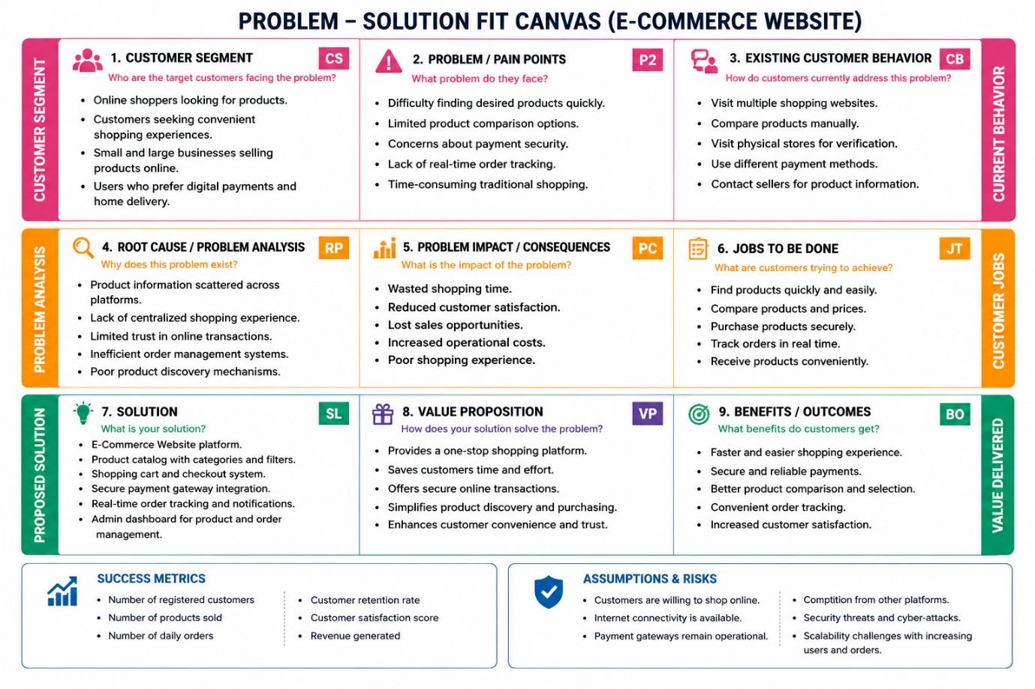
References
- https://www.ideahackers.network/problem-solution-fit-canvas/
- https://medium.com/@epicantus/problem-solution-fit-canvas-aa3dd59cb4fe

